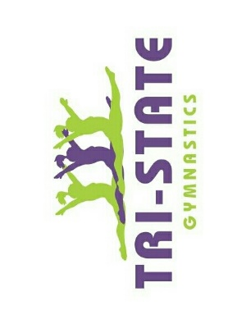
2024 Tri-State Gymnastics End of Year Meet
Rotation Schedule

Friday May 17th
6:00 pm Mini Gym, Preschool, Kindergym, and Developmental Kindergym
7:30pm All D2, D3, and D4-6 Classes

Saturday May 18th
9am all Developmental 1 Classes

Participation in the End of Year meet is FREE of cost but we do ask that you please sign up in the Portal under the EVENTS TAB. Call or stop by the office if you have any questions or issues with the app. Signing up ahead of time will allow us enough time to personalize ribbon cards and get an accurate award counts. All gymnast should wear the NEW TSG leotard that was ordered in February.
All gymnasts will receive:
- Ribbon Card with their Name
- Ribbons awarded based on performance on each event
- Medal Ceremony

