  
  Tri-State Gymnastics
  Offers the ideal Birthday Party for kids 5-13 years of age. The party includes:
  - 1 hour in the gym including the Tumble Track, Trampoline, Pits, and Obstacle Courses.
  - ½ hour in the party room including paper products and drink.
  - Party Hostess
  - No set up or clean-up for you!!!!!!!
  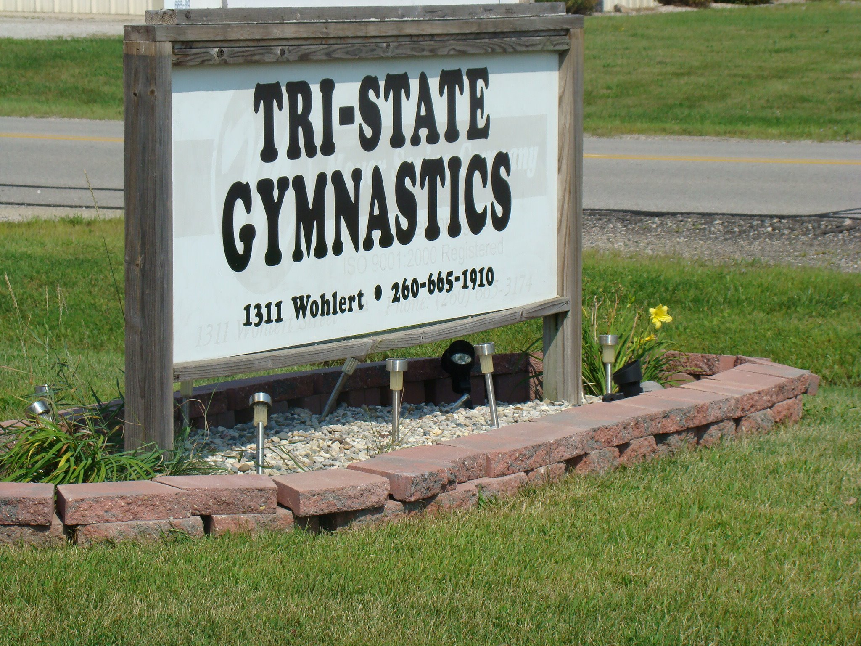
  Prices:
  $205 for 1 ½ hour party
  $
  10 Guests $5.00 each additional guest
  $5.00
  Safe and Fun environment for your party guests
  Book your party today!
  Tri-state gymnastics
  1311 Wohlert Street, Angola Indiana 46703
  (260)665-1910
  
  www.tristategymnastics.com
  Like us on Facebook!

